Prepositional Phrase as a Verb Complement

✅ What Is a Prepositional Phrase as a Verb Complement?
# Source: AI Source: Provided by: [Data Path: Persons Table -> ID Column: 1, Name_En Column: Motasem Essam] -> From: [ChatGPT] on [8/4/2025]
A prepositional phrase can function as a verb complement when it is essential to complete the meaning of the verb—particularly with prepositional verbs (verbs that require a specific preposition to make sense).

🔸 Structure:
# Source: AI Source: Provided by: [Data Path: Persons Table -> ID Column: 1, Name_En Column: Motasem Essam] -> From: [ChatGPT] on [8/4/2025]
- Verb + Prepositional Phrase
- The prepositional phrase often answers “what?”, “whom?”, or “where?” and cannot be omitted without losing meaning.

🔸 Examples:
# Source: AI Source: Provided by: [Data Path: Persons Table -> ID Column: 1, Name_En Column: Motasem Essam] -> From: [ChatGPT] on [8/4/2025]
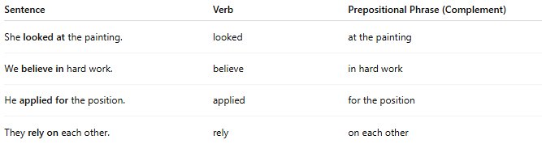
Sentence | Verb | Prepositional Phrase (Complement)
She looked at the painting. | looked | at the painting
We believe in hard work. | believe | in hard work
He applied for the position. | applied | for the position
They rely on each other. | rely | on each other

🔸 Why It's a Verb Complement:
# Source: AI Source: Provided by: [Data Path: Persons Table -> ID Column: 1, Name_En Column: Motasem Essam] -> From: [ChatGPT] on [8/4/2025]
In these examples, the verb is incomplete without the prepositional phrase. For instance:
- ❌ "She looked." (Incomplete – looked where? looked at what?)
- ✅ "She looked at the painting." (Complete)
These prepositional phrases are required by the verbs to form grammatical and meaningful expressions, which qualifies them as verb complements in these contexts.

